# Generative AI Tools for Quantitative Research

## Diagram description for accessibility

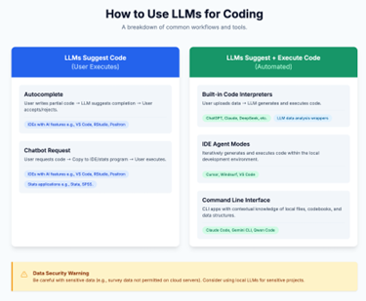

The image is an infographic titled "How to Use LLMs for Coding," which outlines workflows and tools for using Large Language Models in coding. The infographic is divided into two primary sections. The left side is labelled "LLMs Suggest Code (User Executes)" with a blue header, featuring two outlined boxes: "Autocomplete" and "Chatbot Request," along with related links. The right section is titled "LLMs Suggest + Execute Code (Automated)" with a green header, containing descriptions of "Built-in Code Interpreters," "IDE Agent Modes," and "Command Line Interface," along with related links. At the bottom of the image is a yellow warning box highlighting data security concerns with a caution about using LLMs for sensitive projects.

See full resource: <https://www.ncrm.ac.uk/resources/online/all/?id=20859>

National Centre for Research Methods (NCRM)  
Social Sciences  
Murray Building (Bldg 58)  
University of Southampton  
Southampton SO17 1BJ  
United Kingdom

**Web** www.ncrm.ac.uk   
**Email** info@ncrm.ac.uk  
**Tel** +44 23 8059 4539  
**Twitter** @NCRMUK